AT1 Programming Challenge:

Kings Calculator
Freddy Gaffey

Introduction

Provide an overview of the project, its objectives, and its context. What is this, why is it important, who created it etc
The task requirements stipulate for part 1 to design and develop a calculator as that can perform addition, subtraction, multiplication and division. In part 2 a novel logging system that records the time stamp in roman numerals and saves the number of calculations performed as morse code. Finally, a tool to plot a triangle based on a input of two angles and save it to the file. The whole thing was written with clean code and lots of modularity so that the next stages can be easily implemented with minimal refactoring.

Explain the purpose and scope of the documentation. => to be used a a planing tool
The purpose of this documentation is to provide a real-life example of how to write pseudocode so that we are better prepared for the HSC exam. However, its primary goal is to enhance upgradability and reliability. This document is only valid for the previously stipulated task goals.

Outline the structure and organisation of the documentation. => list what will be done
This document is layout in the format where I go through each of the stage starting at P1 which contains pusdocode, flowchart and python code.

Part 1

Flowchart:

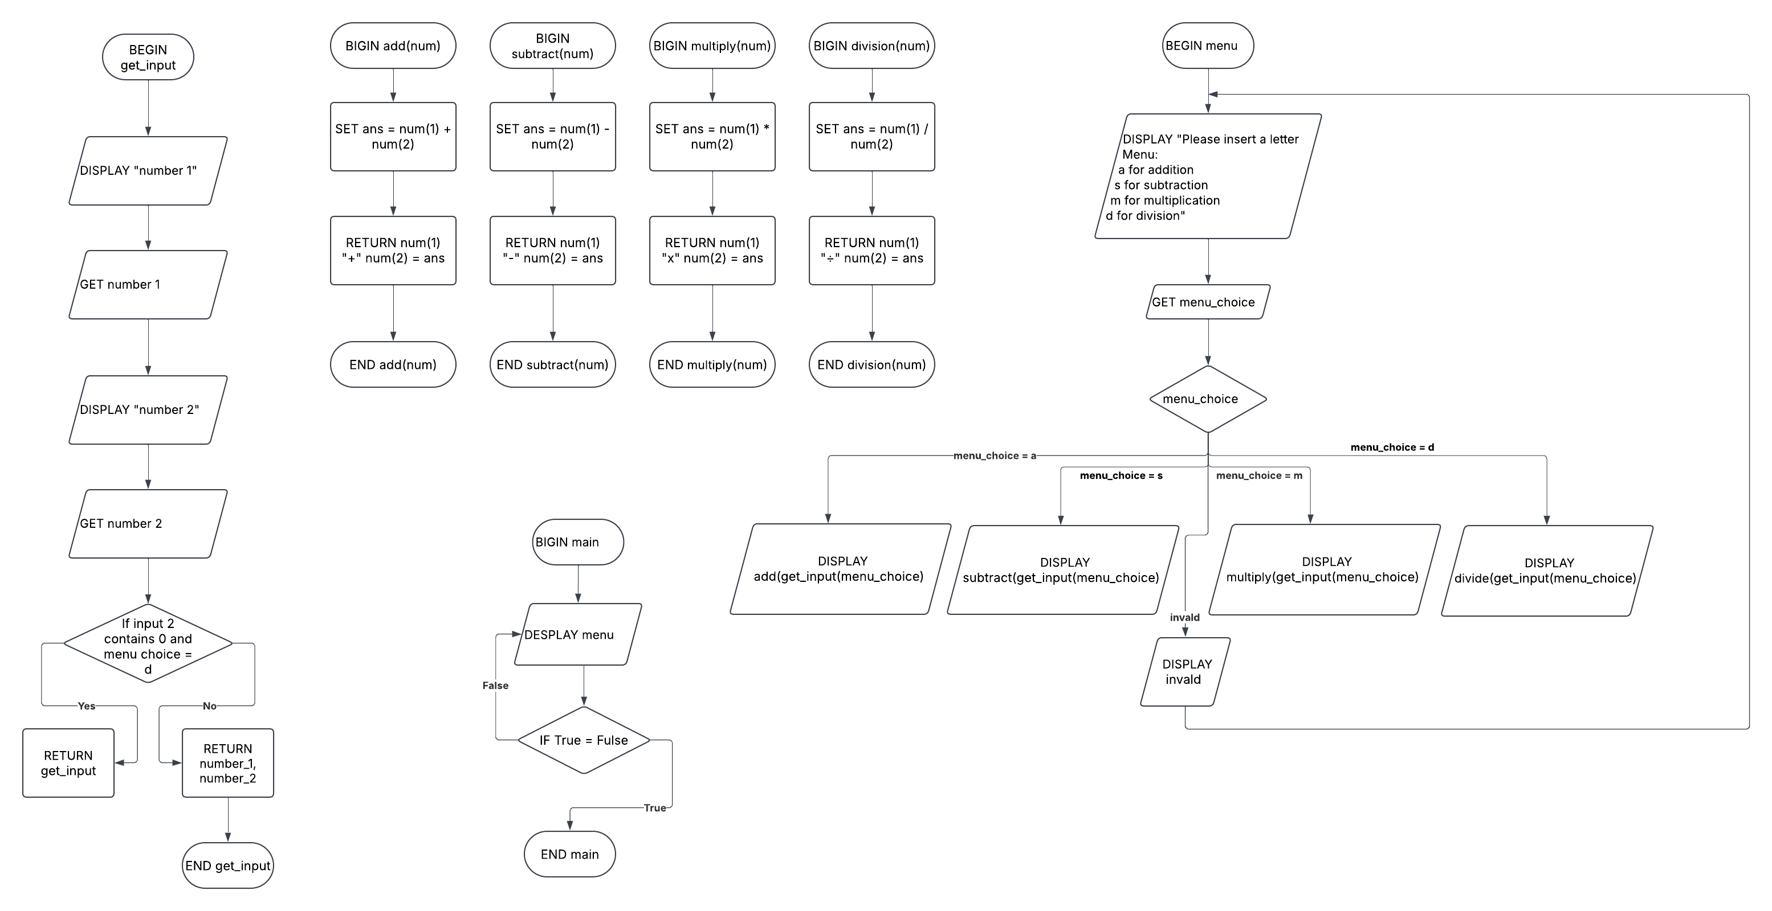

Pseudocode:
BEGIN get_input(menu_choice)
DISPLAY "number 1"
GET number_1
DISPLAY "number 2"
GET number_2

IF menu_choice = d and num(2)=0
DISPLAY you have a zero divisor
RETURN get_input()
ENDIF

RETURN number_1, number_2

END get_input()

BEGIN add(num)
SET ans = num(1) + num(2)
RETURN num(1)+ " + " +num(2) = ans
END add(num)

BEGIN subtract(num)
SET ans = num(1) - num(2)
RETURN num(1)+ " - " +num(2) = ans
END subtract(num)

BEGIN multiply(num)
SET multiply_ans = num(1) * num(2)
RETURN num(1)+ " x " +num(2) = ans
END multiply(num)

BEGIN division(num)
SET ans = num(1) / num(2)
RETURN num(1)+” ÷ “+num(2) = ans
END division

BEGIN menu
DISPLAY "Please insert a letter
Menu:
a for addition
s for subtraction
m for multiplication
d for division
q for quit"

GET menu_choice

CASEWHERE:
a: RETURN add(get_num(menu_choice))
s: RETURN subtract(get_num(menu_choice))
d: RETURN division(get_num(menu_choice))
m: RETURN multiply(get_num(menu_choice))
q: quit
_:

DISPLAY Invalid menu choice
RETURN menu
END menu

BEGIN quit
DISPLAY I hope you had fun doing maths
exit
END quit

Python Code:

Part 2

Flowchart:

Pseudocode:
BEGIN get_input(menu_choice)
DISPLAY "number 1"
GET number_1
DISPLAY "number 2"
GET number_2

IF menu_choice = d and num(2)=0
DISPLAY you have a zero divisor
RETURN get_input()
ENDIF

RETURN number_1, number_2

END get_input()

BEGIN add(num)
SET ans = num(1) + num(2)
RETURN num(1)+ " + " +num(2) = ans
END add(num)

BEGIN subtract(num)
SET ans = num(1) - num(2)
RETURN num(1)+ " - " +num(2) = ans
END subtract(num)

BEGIN multiply(num)
SET multiply_ans = num(1) * num(2)
RETURN num(1)+ " x " +num(2) = ans
END multiply(num)

BEGIN division(num)
SET ans = num(1) / num(2)
RETURN num(1)+” ÷ “+num(2) = ans
END division

BEGIN menu
DISPLAY "Please insert a letter
Menu:
a for addition
s for subtraction
m for multiplication
d for division
q for quit"

GET menu_choice

CASEWHERE:
a: RETURN add(get_num(menu_choice))
s: RETURN subtract(get_num(menu_choice))
d: RETURN division(get_num(menu_choice))
m: RETURN multiply(get_num(menu_choice))
q: quit
_:

DISPLAY Invalid menu choice
RETURN menu
END menu

BEGIN quit
DISPLAY I hope you had fun doing maths
exit
END quit

BEGIN make_file
CREATE calcs.txt
END make_file

BEGIN get_date
RETURN today_date().year, today_date().month, today_date().day
END get_date

BEGIN convert_to_roman_numerals(date)
GET final_date
FOR date = date(1) to date(-1) STEP 1
temp_date = date
roman_date = ""

SET i = ((1000,"M"),(500,"M"),(100,"C"),(50,"L"),(10,"X"),(5,"V"),(1,"I")):

FOR var = 1 to 7 STEP 1:
WHILE temp_date - i(var(0)) >= 0:
roman_date += i(var(1))
temp_date -= i(var(0))
ENDWHILE

# do the optimization like 4 = iv
roman_date = replace(roman_date,"DCCCC", "CM")
roman_date = replace(roman_date,"CCCC", "CD")
roman_date = replace(roman_date,"LXXXX", "XC")
roman_date = replace(roman_date,"XXXX", "XL")
roman_date = replace(roman_date,"VIIII", "IX")
roman_date = replace(roman_date,"IIII", "IV")
REPEAT

append(final_date,roman_date)
final_date = final_date(0) + "." + final_date (1) + "." + final_date(2)
RETURN final_date
END convert_to_roman_numerals(date)

BEGIN deci_to_morse(num_base_10)
morse_dict = { 0 : "-----", 1 : ".----", 2 : "..---", 3 : "...--", 4 : "....-", 5 : ".....", 6 : "-....", 7 : "--...", 8 : "---..", 9 : "----.",}

GET num_base_10_array
num_base_10 = str(num_base_10)
FOR i to length.num_base_10 STEP 1:
append(num_base_10_array,num_base_10(i))

GET num_base_morce

FOR number in num_base_10_array:
num_base_morce = num_base_morce + " " + morse_dict(number)

RETURN num_base_morce
END deci_to_morse(num_base_10)

BEGIN main
make_file

WHILE True
DISPLAY menu
ENDWHILE
END main

Python code:

Part 3

Flowchart:

Pseudocode:

Python code:

